**CommonJS modules**

**Slide 4 & 5**

Create a folder called WEEK2 in vscode

hello.js

const message = 'Hello';

exports.sayHello = function(){

   console.log(message);

}

Server.js

const hello = require('./hello');

hello.sayHello();

open the terminal and run the following command to execute it

node server.js

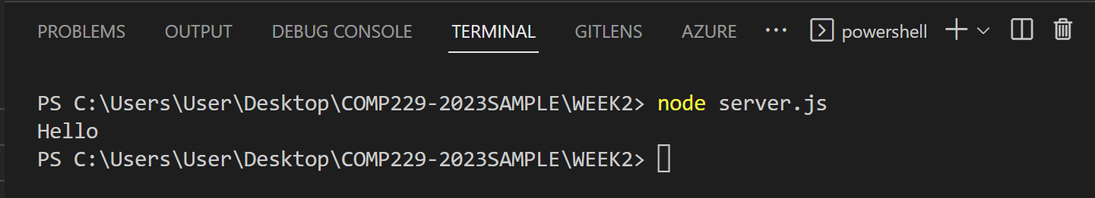

OR

**Slide 6**

hello.js

module.exports = function() {

    const message = 'Hello';

    console.log(message);

 }

Server.js

const hello = require('./hello');

hello();

open the terminal and run the following command to execute it

node server.js

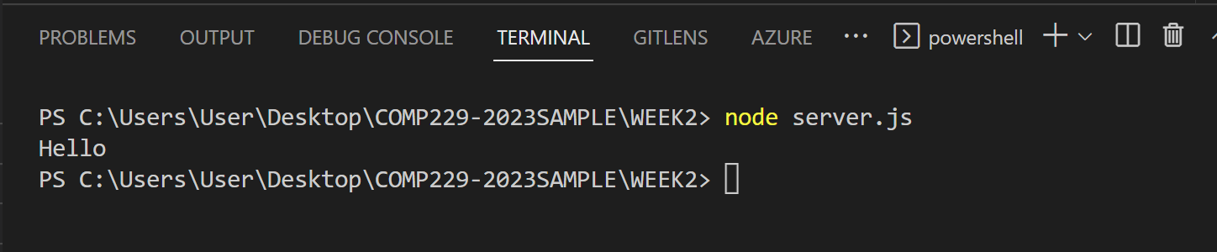

**Developing Node.js web applications**

Slide 4

Server.js

const http = require('http');

http.createServer((req, res) => {

   res.writeHead(200, {

   'Content-Type': 'text/plain'

   });

   res.end('Hello World');

}).listen(3000);

console.log('Server running at http://localhost:3000/');

open the terminal and run the following command to execute it

node server.js or node server

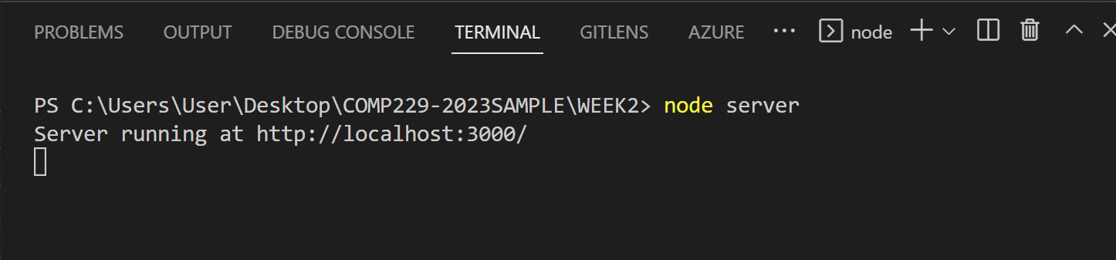

**Meet the Connect module**

Slide 11 & 12

Server.js

const connect = require('connect');

const app = connect();

app.listen(3000);

console.log('Server running at http://localhost:3000/');

open the terminal and run the following command to execute it

node server.js or node server

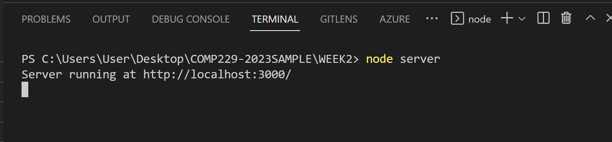

Slide 13 & 14 - connect Middleware

const connect = require('connect');

const app = connect();

function helloWorld(req, res, next) {

   res.setHeader('Content-Type', 'text/plain');

   res.end('Hello World');

};

app.use(helloWorld);

app.listen(3000);

console.log('Server running at http://localhost:3000/');

open the terminal and run the following command to execute it

node server.js or node server

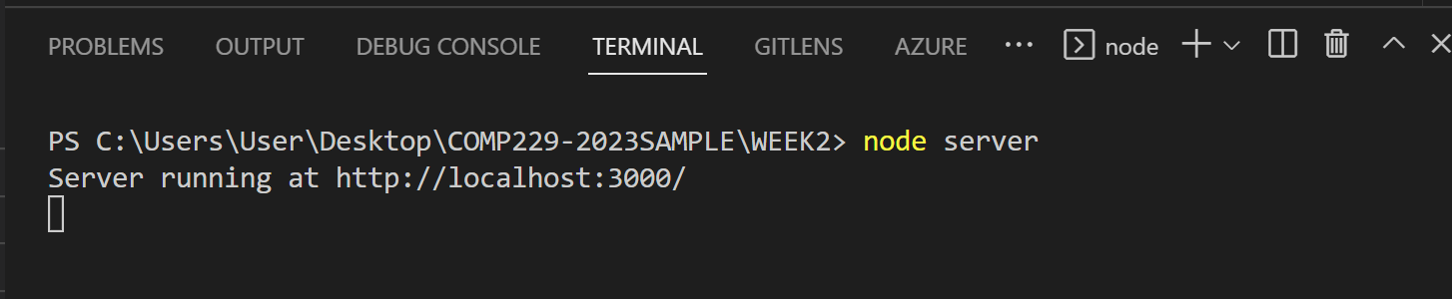

Slide 15 – 19 Mounting Connect Middleware

Server.js

const connect = require('connect');

const app = connect();

function logger(req, res, next){

    console.log(req.method, req.url);

    next();

};

function helloWorld(req, res, next){

    res.setHeader('Content-Type', 'text/plain');

    res.end('Hello World');

};

function goodbyeWorld(req,res,next){

    res.setHeader('Content-Type', 'text/plain');

    res.end('Goodbye World');

};

app.use(logger);

app.use('/hello', helloWorld);

app.listen(3000);

console.log('Server running at http://localhost:3000/');

open the terminal and run the following command to execute it

node server.js or node server

